RD Template

Group 20

Ian Guincho

Tony Liu

Christopher Alvarez

Ardonniss Zimero

Overview

The game is called Aurelia and is a 2d pixelated platformer similar to Celeste with a series of levels that the player has to complete as the objective of the game. The player should be able to run, jump, climb and dash while avoiding death by fall and death by traps in order to complete the level. If the player fails to complete the level, the player should automatically be put back at the spawn point in that level. Once the player completes the level, the level progress should be saved so that the player can continue from the next level. There will be animations for running, jumping, turning, etc in order to make the gameplay feel more realistic. In addition to player animations, there will also be game animations such as death transitions, camera shakes, button animations and more.

There is a main menu and a pause menu incorporated into the game so that the player can pause, change keybinds, change resolution, and adjust volume at any time they want to. There are various checkpoints in the levels that save the player's progress if they touch it. This is saved using the PlayerPrefs and saved progress can be loaded in using the load button at the main menu. The resolution should be able to detect the player's monitor screen size and automatically adjust to that resolution. There will be a vsync option that automatically synchronizes the refresh rate and frame rate of the monitor in order to stop screen tearing.

Functional Requirements

1. Player Movement - The player must be able to run, climb, jump, and dash as well as access the pause menu. (High)
2. Level Progression - The player should be able to traverse through different maps (High)
3. Player Obstacles- The levels must have obstacles such as traps and spikes that offer a challenge to the player. When the player encounters these obstacles, the player will die and respawn at the start of the level. Death by fall is also considered an obstacle in our game. Whenever the player falls into an endless pit, the player should be able to respawn at the start of the level. (High)
4. Vsync(on) - The game should be able to automatically synchronize the refresh rate and the frame rate of the monitor so that players will not have any screen tearing.(Medium)
5. Vsync(off) - The game should run at the highest frame possible on the player's device. (Medium)
6. Resolution - It should be able to automatically adjust to the player's native resolution for maximum performance. (Medium)
7. Volume Slider - The slider adjusts the volume for the player in 3 categories; master, music and sfx. (Low)

Non-functional Requirements

1. Save and Load State - Our game has now incorporated a save and load system that allows the player to continue where they left off on levels through the use of a checkpoint.(Medium)
2. Options- the game will have a full suite of options including graphics, audio, and key binding (High)
3. Player Movement - The player movement should feel responsive and be easy to use (High)

**Use case and sequence diagram are on the next pages**

Use Case Diagram

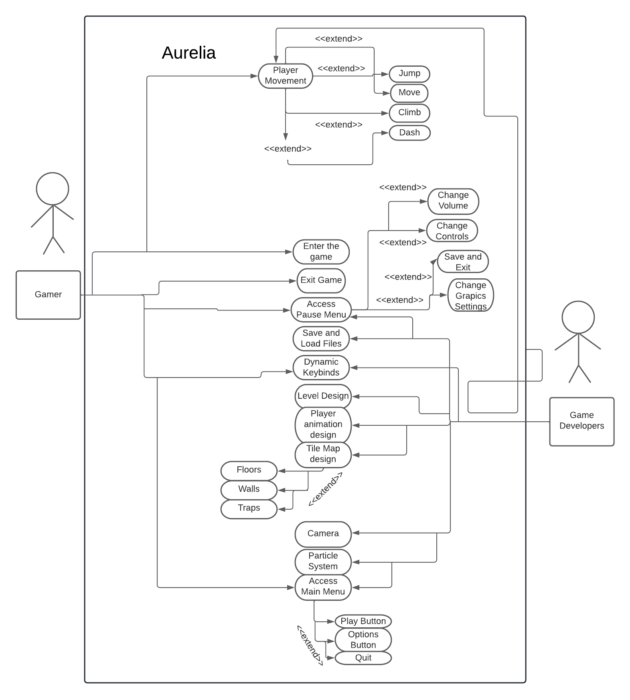

Sequence Diagram

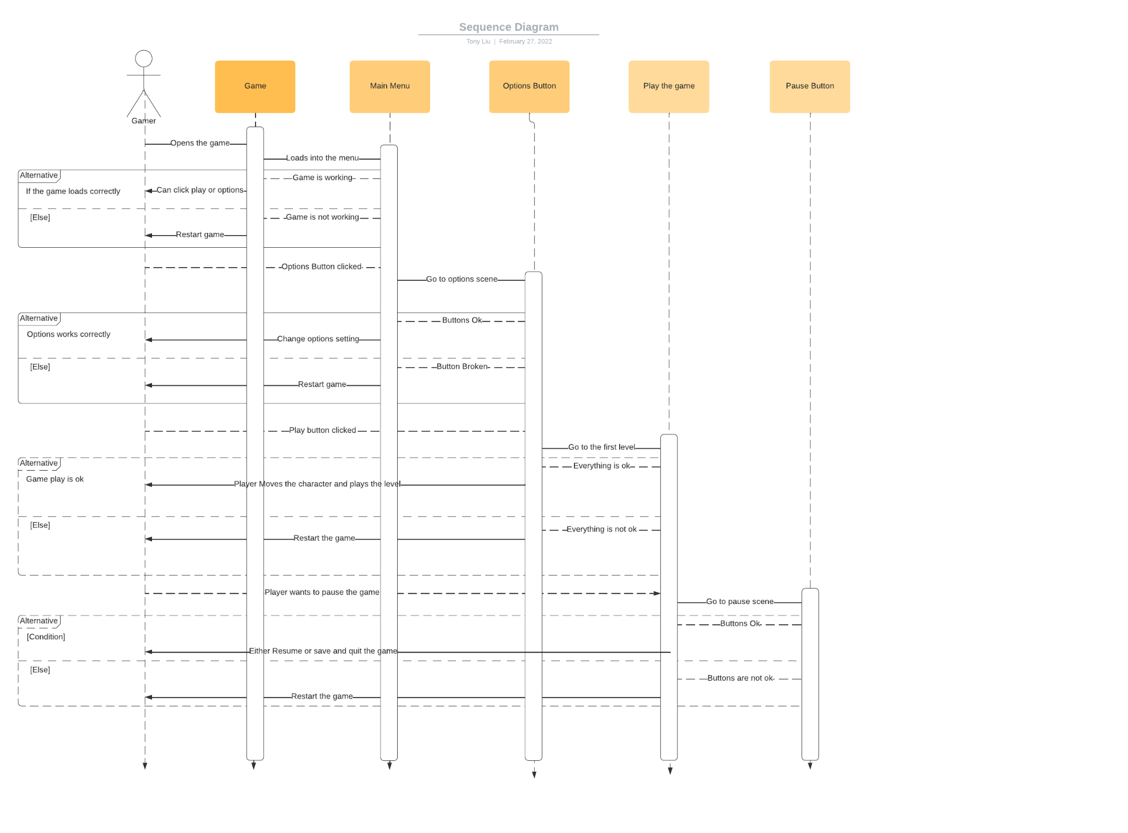

Operating Environment

The game should run on most pc’s running Windows or mac os.

Assumptions and Dependencies

As of now, there are no assumed factors that could affect the requirements in this document. Our project also has no dependencies on external factors as of now, everything is within unity and visual studios.